## ****HIGH LEVEL DESIGN****

## ****Entity-Relationship Diagram (ERD) Document****

**Project Title:** Project X  
**Version:** 1.0  
**Prepared by:** Team ABE  
**Date:** May 14, 2025

### ****1. Introduction****

This document outlines the Entity-Relationship Diagram (ERD) for the Attendance Management System. The system supports secure login, role-based access, course scheduling, and QR-based attendance tracking for students and lecturers. This ERD models the data entities and their relationships, which form the foundation of the system's database layer.

### ****2. Entities and Attributes****

#### ****2.1. User****

Represents all users of the system regardless of role.

|  |  |  |  |
| --- | --- | --- | --- |
| **Field** | **Type** | **Key** | **Description** |
| user_id | UUID/Int | Primary Key (PK) | Unique identifier for the user |
| first_name | String |  | First name |
| last_name | String |  | Last name |
| email | String |  | Email address |
| username | String |  | Login username |
| password | String |  | Hashed password |
| role | String |  | Role type (e.g., student, lecturer) |

#### ****2.2. Role_Type****

Defines specific user roles for normalization.

|  |  |  |  |
| --- | --- | --- | --- |
| **Field** | **Type** | **Key** | **Description** |
| role_id | Int | Primary Key (PK) | Role identifier |
| user_id | Int | Foreign Key (FK) | References User.user_id |

#### ****2.3. Student****

Inherits from User and stores student-specific records.

|  |  |  |  |
| --- | --- | --- | --- |
| **Field** | **Type** | **Key** | **Description** |
| role_id | Int | Primary Key (PK) | Role identifier |
| user_id | Int | Foreign Key (FK) | References User.user_id |

#### ****2.4. Lecturer****

Inherits from User and stores lecturer-specific records.

|  |  |  |  |
| --- | --- | --- | --- |
| **Field** | **Type** | **Key** | **Description** |
| role_id | Int | Primary Key (PK) | Role identifier |
| user_id | Int | Foreign Key (FK) | References User.user_id |

#### ****2.5. Administrator****

Inherits from User and stores admin-specific records.

|  |  |  |  |
| --- | --- | --- | --- |
| **Field** | **Type** | **Key** | **Description** |
| role_id | Int | Primary Key (PK) | Role identifier |
| user_id | Int | Foreign Key (FK) | References User.user_id |

#### ****2.6. Course****

Represents a course offered in the system.

|  |  |  |  |
| --- | --- | --- | --- |
| **Field** | **Type** | **Key** | **Description** |
| course_id | Int | Primary Key (PK) | Unique course ID |
| course_code | String |  | Alphanumeric course code |
| course_name | String |  | Course title |
| description | Text |  | Optional description of the course |
| lecturer_id | Int | Foreign Key (FK) | References Lecturer.lecturer_id |
| schedule_id | Int | Foreign Key (FK) | References Schedule.schedule_id |
| student_list | Text/JSON |  | List of student IDs enrolled |

#### ****2.7. Schedule****

Details when a course occurs.

|  |  |  |  |
| --- | --- | --- | --- |
| **Field** | **Type** | **Key** | **Description** |
| course_id | Int | Primary Key (PK) | Unique course ID |
| course_code | String |  | Alphanumeric course code |
| course_name | String |  | Course title |
| description | Text |  | Optional description of the course |
| lecturer_id | Int | Foreign Key (FK) | References Lecturer.lecturer_id |
| schedule_id | Int | Foreign Key (FK) | References Schedule.schedule_id |
| student_list | Text/JSON |  | List of student IDs enrolled |

#### ****2.8. Attendance****

Records attendance via QR code for each course.

|  |  |  |  |
| --- | --- | --- | --- |
| **Field** | **Type** | **Key** | **Description** |
| course_id | Int | Primary Key (PK) | Unique course ID |
| course_code | String |  | Alphanumeric course code |
| course_name | String |  | Course title |
| description | Text |  | Optional description of the course |
| lecturer_id | Int | Foreign Key (FK) | References Lecturer.lecturer_id |
| schedule_id | Int | Foreign Key (FK) | References Schedule.schedule_id |
| student_list | Text/JSON |  | List of student IDs enrolled |

#### ****2.9. Login_Audit****

Tracks user login activity.

|  |  |  |  |
| --- | --- | --- | --- |
| **Field** | **Type** | **Key** | **Description** |
| login_id | Int | Primary Key (PK) | Unique login record |
| user_id | Int | Foreign Key (FK) | References User.user_id |
| time | Time |  | Login time |
| day | String |  | Day of login |
| username | String |  | Redundant for logging purposes |

### ****3. Relationships Overview****

A **User** has one **Role_Type**.

A **Role_Type** can be a **Student**, **Lecturer**, or **Administrator**.

A **Course** is taught by one **Lecturer** and has one **Schedule**.

A **Schedule** is linked to a **Course** and a **Lecturer**.

**Attendance** is tied to both **Course** and **Lecturer**, and stores QR metadata.

**Login_Audit** logs each login event with reference to a **User**.

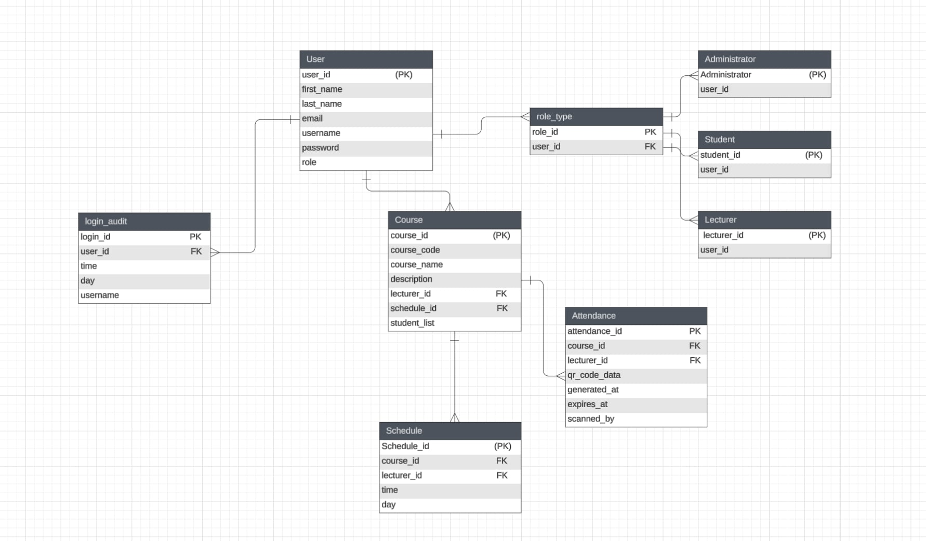

### ****4. Conclusion****

This ERD document outlines a normalized and role-based data structure for the Attendance Management System. It ensures efficient data retrieval, extensibility for new features (e.g., reporting), and compliance with common software architecture principles.